Abstract Template for the Inertial Sensors and Applications 2026
The entire abstract (including images, title, authors and institutions line) must not exceed 2 pages!
Font size, borders and line spacing must not be reduced; Minimum abstract size is 1 page!
Use the predefined paragraph styles named ISA-Title, ISA-Authors, ISA-Section, ISA-Text.
Submission:
Please upload your abstract (word document with max 2 pages) electronically before July 20, 2026 using our EasyChair submission website https://easychair.org/conferences/?conf=dgonisa2026
Title of your Abstract (Style: ISA-Title)
L. Author¹, M. Speaker², T. Author^{2,3} (Style: ISA-Authors)
¹ Karlsruhe Institute of Technology, Institute of Systems Optimization, Fritz.Haber-Weg 1, 76131 Karlsruhe, GERMANY (Style: ISA-Address)
² The Gyro Manufacturers, Division 4, 4332 TomTom Rd, London, UK
³ Z-Green Technologies, Department of green fiber technologies, Science Park 23, District Changping 102200, Beijing, CHINA

Abstract (Style: ISA-Section)
This paper illustrates the desired format and content of the abstracts for the conference Inertial Sensors and Applications to be held in Braunschweig, Germany. (Style: ISA-Text)
Document format
The document size is A4 (210x297mm). Borders are 20mm top, 15mm bottom and 10mm (left & right sides). The paragraph styles ISA-Title, ISA-Authors, ISA-Address and ISA-Text are predefined. Please use them to achieve the correct format of the document. The used text font is the sans serif font Arial of 12pt size.
Document styles
All predefined styles for the abstract are named “ISA-...”. You can display the Styles and Formatting Window (see below) by pressing the Function Key F11. Shrink the “Default Style” Selection (+/-)
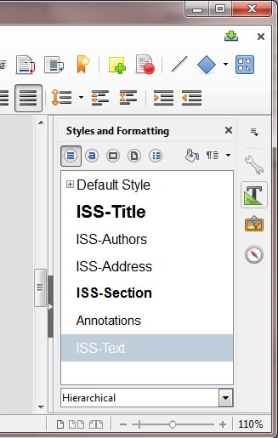
Figure 1. Predefined styles of the ISA abstract template.
Document title
Consider a short paper title containing the main keywords of the work. Use the style ISA-Title for the document title. The paper title must not change when submitting the full paper! Do not use product names like for example “Performance improvement of the STX422” as nobody knows what STX422 is meant to be.
Authors
Authors shall be mentioned with their first name initial, followed by the name. The lead-author must be mentioned first. Underline the speaker (person presenting the paper at the conference). If authors from multiple institutions contribute to the paper please assign them to their company with superscript indices ¹, ² etc. as the example above shows. Indices are not needed if all authors belong to the same institution. Use the style ISA-Authors for the authors line.
Company address line
Full postal address of the institution(s) – no e-mail, no phone, no fax, no website URL. Use superscript indices ¹, ² etc. for the assignment to the authors if multiple institutions are involved. Use the style ISA-Address for the address line.
Sections
Your abstract may contain several sections. However the first section is always named “Abstract”. Use the style ISA-Section for the sections.
Content
The abstract shall provide a significant overview of the scope and content of the scientific contribution. Please indicate what type of research approach is intended to be covered (theoretical, simulative and/or experimental) and what result evaluation methods will be used. Furthermore it is very much appreciated if the authors provide information about what kind of result is achieved or expected (e.g. by inclusion of an example figure of the type of result). Use the style ISA-Text.
Second page
The entire abstract (including images, Title, Authors and Institutions line) must not exceed 2 pages! Font size, borders and line spacing must not be reduced!
Images & Figures
To keep the document size in a reasonable size, insert your images with a resolution between 200-400dpi (dots per inch).
- Avoid screen shots as they are mostly below 100dpi.
- Avoid images / graphs with dark background color.
- Do not use copy and paste to insert an image from another application. Always save / export the image from the source application e.g. as jpg, png, gif …, and afterwards use the “insert image” dialog of writer.
- Do not use transparency in your images as transparency is not allowed in IEEE PDF/A compatible documents.

